|  |
| --- |
| NAME: Ayush Vinod Upadhyay  ROLL NO: I025  SAP ID: 60003220131  BRANCH: Information Technology |

**Experiment No:8**

**To Examine the consistency of database using concurrency control technique (Locks)**

**------------------------------------------------EXERCISE--------------------------------------------**

1.

CREATE TABLE EMPLOYEE(

FNAME VARCHAR(20),

LNAME VARCHAR(20),

SALARY VARCHAR(20),

DEPT VARCHAR(20),

DOB DATE,

CITY VARCHAR(20)

);

2.

INSERT INTO EMPLOYEE VALUES('ADAM', 'A', 1000, 'ACCOUNTS', 07-11-2022, 'MUMBAI');

INSERT INTO EMPLOYEE VALUES('BANDA', 'B', 10, 'HR', 07-11-2022, 'MUMBAI');

INSERT INTO EMPLOYEE VALUES('CAROL', 'C', 10, 'ADMIN', 07-11-2022, 'MUMBAI');

INSERT INTO EMPLOYEE VALUES('GREENE', 'G', 5000, 'TECHNICAL', 07-11-2022, 'MUMBAI');

INSERT INTO EMPLOYEE VALUES('TOM', 'T', 500, 'TECHNICAL', 07-11-2022, 'MUMBAI');

3.

SAVEPOINT A;

INSERT INTO EMPLOYEE VALUES('RAHUL', 'C', 10, 'HR', 08-11-2022, 'MUMBAI');

SAVEPOINT B;

INSERT INTO EMPLOYEE VALUES('RAMESH', 'F', 10, 'HR', 08-11-2022, 'MUMBAI');

SAVEPOINT C;

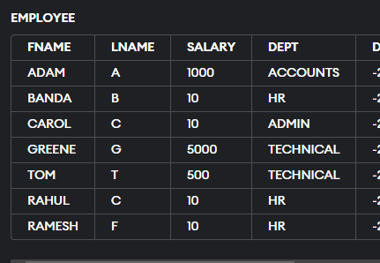

4. ROLLBACK TO B;

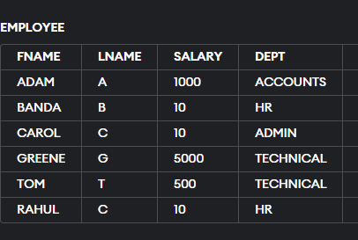

ROLLBACK TO A;

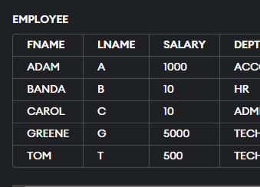

5.COMMIT;

INSERT INTO EMPLOYEE VALUES('RAAJ', 'P', 500, 'TECHNICAL', 07-11-2022, 'MUMBAI');

SAVEPOINT P;

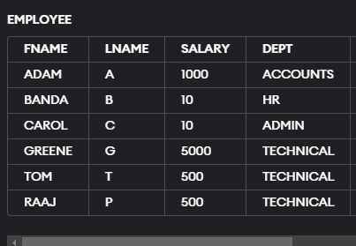

UPDATE EMPLOYEE

SET LNAME='PAUL'

WHERE FNAME = 'BANDA';

SAVEPOINT X;

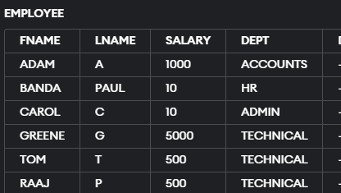

UPDATE EMPLOYEE

SET LNAME='PAUL'

WHERE FNAME = 'GREENE';

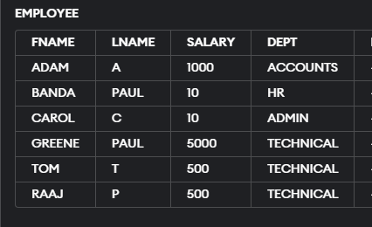

ROLLBACK TO X;



10.

UPDATE EMPLOYEE

SET SALARY = 1.05*SALARY;

SAVEPOINT A;

UPDATE EMPLOYEE

SET SALARY = 1.05*SALARY;

SAVEPOINT B;

UPDATE EMPLOYEE

SET SALARY = 1.05*SALARY;

SAVEPOINT C;